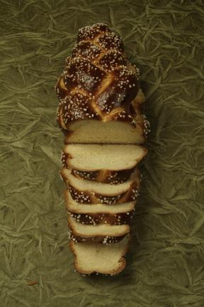
Challah

Total dough yield
Formula adjustment needed depending on group size each student will produce 1x 5 strand 120g and 1x 6 strand 114g
Overall pre-fermented flour
0%

Hitz, C. (n.d.). Challah photograph.

Final Dough
 | Metric (g) | U.S. Standard | Final Dough % | Resized Yield
Bread flour | 2765 | 6# 1.5 oz | 100
Water | 520 | 1# 2.3 oz | 18.8
Yolks | 173 | 6.1 oz | 6.2
Eggs | 629 | 1# 6 oz | 22.7
Honey | 167 | 5.8 oz | 6
Oil | 256 | 9 oz | 9.2
Instant osmotolernat yeast | 47 | 1.6 oz | 1.6
Salt | 59 | 2 oz | 2.1
Sugar | 312 | 11 oz | 11.2
Total Dough | 4928 | 10# 13.8 oz | 177.8

Desired dough temperature: 75-78˚ F

Method of Preparation:

- Mix all ingredients on 1st speed in a spiral mixer for 4 minutes.
- Mix an additional 4-6 minutes on 2nd speed.
- Ferment for 30-40 minutes at room temperature, then place in fridge.
- After 2 hours punch down dough.
- Wrap proofing tub in plastic, return to fridge and let ferment overnight.
- The following day, divide the dough into 170g units for three braid loaves and 114g for six braid loaves.
- Shape into bâtards and allow to rest for 20 minutes.
- Roll the pre-shapes into 12-18” logs with the center thicker than the ends.
- Braid so the loaf is thicker in the middle and tapered on both ends.
- Place on parchment lined sheet pans and egg wash.
- Place in proof box for 60-75 minutes.
- Brush with egg wash, and sprinkle with poppy or sesame seeds if desired, and bake in a convection oven for 25-30 minutes at 325°.

